 | TO:  FR:  DT:  RE: | Portfolio  Katarina Hung  04 March 2025  Research Design Plan

This memo is intended to outline the Design Plan Report for usability group 3. Thie RDP presents a structured approach to assessing ClawWorldUSA.com, an arcade and event venue in Las Vegas, Nevada. This RDP will provide background information, a preliminary evaluation, and testing goals for ClawWorldUSA.com. Our goal is to evaluate how effectively the website conveys its unique selling points—arcade gameplay, event bookings, product promotions—and identify opportunities to improve the online user experience.

Background
ClawWorldUSA.com is an arcade and event venue in Las Vegas, Nevada. It’s known for its date-night fun, birthday party packages, and family friendly entertainment. Claw World features trendy offerings such as TikTok famous ice cream flavors, and collectible Pop Mart Labubu designer toys.

Preliminary Evaluation
Upon our initial visit to ClawWorldUSA.com it’s evident that this website has a more static than dynamic feel to it. Its main page delivers a straightforward UI by displaying its menu options in a row at the top of the page, featuring the following tabs:
- HOME
- VIP MEMBER BENEFITS
- POP MART PRODUCTS
- PRIVATE PARTY BOOKING
- AVAILABLE ONLINE
Also, on the home page, after a large photo of the interior of Claw World, are some vertically oriented phone videos displaying the various games found at Claw World. This is followed by a map showing its location and general contact information. The other menu options are similar in that they are all static, short pages, displaying information in the most straightforward manner.

This website is very good at getting to the point and sticking to a two-color color palette for the site. However, the website is disorganized in what information is displayed under each menu option. The website would also benefit from more visual displays of what it offers. Additionally, it can be improved visually.

Testing Goals
We plan to evaluate the following areas:
- Content Organization—Can you user find information they’re looking for under the menu option most fitting to display said information?
- Dynamic Pages—Are the website pages engaging to the user’s eye?
- Photos/Videos—Are there enough good visual representations (through the use of photos and videos) of Claw World that gives the user a good and exciting idea of the business?
- Visual Elements—Do the color palettes and over design of the website add to the user experience without being too distracting?

Method
We will be testing a group of around 5-10 people. We will ask each participant to access the website either on their phone or on a computer/laptop. Once at the site, we will ask participants to find specific information, then ask them to rate how easy or hard it was to locate the information. We will also ask participants to view the given photos and videos currently on the website. Afterwards we will ask the participants to share their opinion and/or rate the websites visual elements, including the design and photos and videos they viewed.

Before we test the participants, we will collect their demographic information to ensure they match our typical user profile. We will also collect information in relation to arcades and claw machines to determine how relevant the data we collect from them will be. While we are testing them, we will be collecting information regarding the usability of the website and the aesthetic appeal of it. After the testing, we will be collecting the data in a scaling basis.

To accurately collect information, and to give the participants time to think about their answers, we will be administering a written questionnaire for each participant.

Potential Obstacles
It may be difficult to find participants who align with our typical user profile. To mitigate this, we plan to interview a large number to people and filter out those who do not fit our Claw World’s target demographic.

Schedule
We will be meeting every week starting on March 1, 2025 to complete the each portion of this project. Our schedule is as follows:

- March 5th – 7th – Complete testing questionnaire
- March 8th & 9th – Complete final draft of RDP
- March 9th – Submit final draft of RDP
- March 10th -12th – Collect participants for user testing
- March 13th – Distribute questionnaire to participants
- March 14th – Collect and analyze questionnaire
- March 15th&16th – Complete Progress Report
- March 16th – Submit Progress Report
- March 17th – 30th – Complete Final Report
- March 30th – Submit Final Report

Key Milestones:
- Design Plan Report Final Draft – March 9th, 2025
- Progress Report – March 16th, 2025
- Final Report – March 30th, 2025
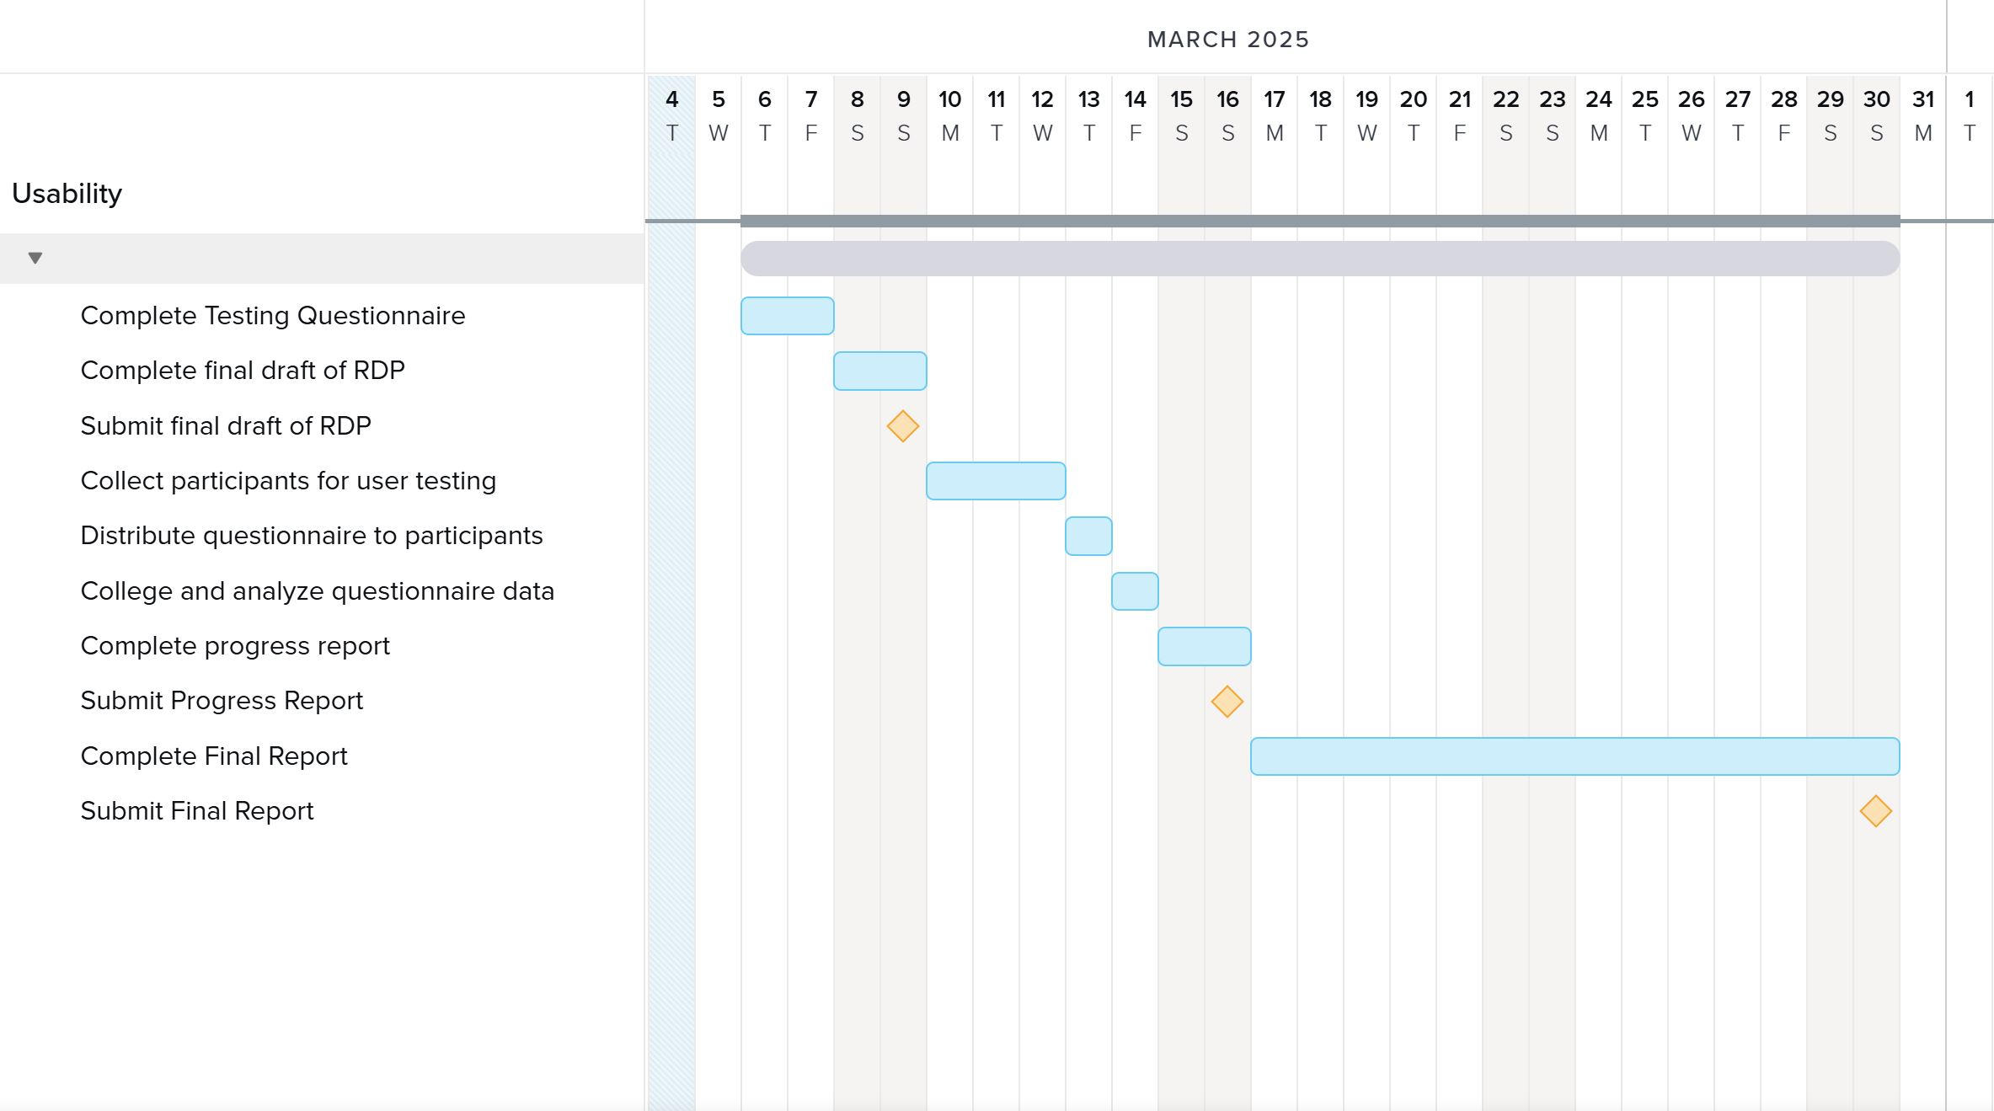

Conclusion
This report outlines a usability evaluation of ClawWorldUSA.com, focusing on key user tasks. Through user testing, we aim to identify design and navigational improvements that enhance user satisfaction and their online experience. Please feel free to reach out with and questions or concerns via email: [REDACTED]

Attachment
Testing Questionnaire:
Pre-Test
- What is your age group?
  - Under 18
  - 18-24
  - 25-34
  - 35-44
  - 45+
- How often do you visit arcades?
  - Never
  - Rarely
  - Occasionally
  - Regularly
- Which device are you using for this test?
  - Desktop/laptop
  - Tablet
  - Phone
- Have you visited Claw World before?
  - Yes
  - No

Navigation and Content Organization
- Were you able to find the information you were looking for easily?
  - Yes
  - No
  - Somewhat
- Do the menu labels match your expectations for where certain information was?
  - Yes
  - No (please specify)
- How would you rate the ease of navigation of this website?
  - Very easy
  - Somewhat easy
  - Neutral
  - Somewhat difficult
  - Very difficult

Visual Engagement
- How visually engaging do you find the website?
  - Very engaging
  - Somewhat engaging
  - Neutral
  - Not very engaging
  - Not engaging at all
- Do you pages feel dynamic and fun, fitting an arcade experience?
  - Yes
  - No
  - Somewhat
- Do the photos and videos on the website give you a good idea of what Claw World is like?
  - Yes
  - No
  - Somewhat
- Would you like to see more photos or videos of the arcade and games
  - Yes
  - No
  - No preference

Overall Design
- Do the colors and overall design enhance the user experience without being distracting?
  - Yes
  - No
- How would you describe the overall design of the website (Multiple selection)
  - Fun and exciting
  - Clean and easy to use
  - Too cluttered
  - Boring and needs more visuals
  - Other (please specify)

